**Temperature Converter**

**CODE:**

**<!DOCTYPE html>**

**<html>**

**<head>**

**<title>Temperature Converter</title>**

**<style>**

**body {**

**font-family: Arial, sans-serif;**

**width: 300px;**

**margin: 50px auto;**

**padding: 20px;**

**border: 1px solid #ccc;**

**border-radius: 8px;**

**}**

**label, input, button {**

**display: block;**

**width: 100%;**

**margin-bottom: 10px;**

**}**

**#result {**

**margin-top: 10px;**

**font-weight: bold;**

**}**

**</style>**

**</head>**

**<body>**

**<h2>Temperature Converter</h2>**

**<label for="tempInput">Enter Temperature:</label>**

**<input type="number" id="tempInput" placeholder="Enter value" />**

**<button onclick="convertToCelsius()">Convert to Celsius</button>**

**<button onclick="convertToFahrenheit()">Convert to Fahrenheit</button>**

**<div id="result">Result: </div>**

**<script>**

**function convertToCelsius() {**

**const temp = parseFloat(document.getElementById('tempInput').value);**

**if (isNaN(temp)) {**

**document.getElementById('result').textContent = "Please enter a valid number";**

**} else {**

**const celsius = (temp - 32) * 5/9;**

**document.getElementById('result').textContent = `Result: ${celsius.toFixed(2)} °C`;**

**}**

**}**

**function convertToFahrenheit() {**

**const temp = parseFloat(document.getElementById('tempInput').value);**

**if (isNaN(temp)) {**

**document.getElementById('result').textContent = "Please enter a valid number";**

**} else {**

**const fahrenheit = (temp * 9/5) + 32;**

**document.getElementById('result').textContent = `Result: ${fahrenheit.toFixed(2)} °F`;**

**}**

**}**

**</script>**

**</body>**

**</html>**

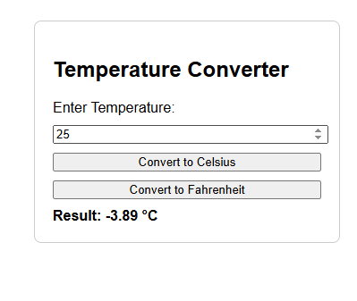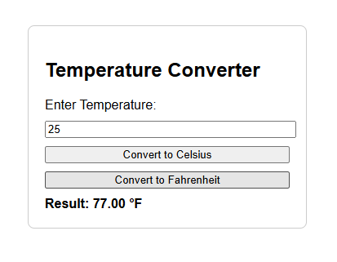**OUTPUT:**